9. ReactJS-HOL

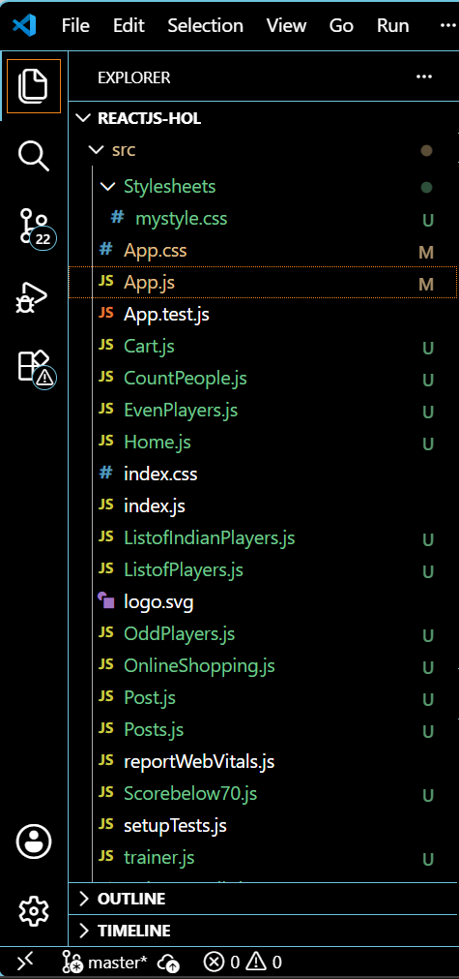

ListofPlayers.js
import React from 'react';

function ListofPlayers({ players }) {
return (
<div>
{players.map((item, index) => (
<li key={index}>Mr. {item.name} <span>{item.score}</span></li>
))}
</div>
);
}
export default ListofPlayers;

ListofIndianPlayers.js
import React from 'react';

function ListofIndianPlayers({ IndianPlayers }) {
return (
<ul>
{IndianPlayers.map((item, index) => (
<li key={index}>{item}</li>
))}
</ul>
);
}
export default ListofIndianPlayers;

OddPlayers.js
import React from 'react';

function OddPlayers([first, , third, , fifth]) {
return (
<ul>
<li>First : {first}</li>
<li>Third : {third}</li>
<li>Fifth : {fifth}</li>
</ul>
);
}
export default OddPlayers;

EvenPlayers.js
import React from 'react';

function EvenPlayers([, second, , fourth, , sixth]) {
return (
<div>
<li>Second : {second}</li>
<li>Fourth : {fourth}</li>
<li>Sixth : {sixth}</li>
</div>
);
}
export default EvenPlayers;

Scorebelow70.js
import React from 'react';

function Scorebelow70({ players }) {
const filteredPlayers = players.filter(player => player.score <= 70);
return (
<div>
{filteredPlayers.map((item, index) => (
<li key={index}>Mr. {item.name} <span>{item.score}</span></li>
))}
</div>
);
}
export default Scorebelow70;

OUTPUT:
